VisionClassify
(Generic Image Classifier using CNN)

24MIS0237 | Arsh Ali
24MIS0289 | Vallabh Susvar
24MIS0261 | Sanika Patil

Project Overview:
VisionClassify is a Generic Image Classification System that uses a Convolutional Neural Network (CNN) to automatically identify and classify images into Pre-Defined Categories.
The system takes a dataset containing images organized into different class folders. The images are resized to 128 × 128 pixels and normalized before being provided to the CNN model. The model learns visual patterns such as edges, shapes, textures, and higher-level features from the training images.
The project uses a CNN consisting of multiple Convolutional and Max-Pooling layers, followed by Fully Connected (Dense) layers. The final ‘Softmax’ Layer assigns Probabilities to each available class and determines the Predicted Category.
The dataset is divided into 80% Training and 20% Validation data. After Training for multiple Epochs, the system evaluates the model using the Validation Dataset and displays Training and Validation Accuracy and Loss Graphs to help analyse the Model Performance. The Trained Model is finally saved as an ‘.keras’ file for future image classification.
The key features of the System include:
- Generic Image Classification – Can classify images into multiple user-defined categories.
- CNN-Based Model – Automatically learns important Visual Features from images.
- Folder-Based Dataset – Classes are automatically detected from dataset folders.
- Image Preprocessing – Images are Resized and Normalized before training.
- Performance Evaluation – Calculates Validation Accuracy and Loss.
- Training Visualization – Displays Accuracy and Loss Graphs for Training and Validation.
- Model Saving – Saves the trained model as ‘image_classifier.keras’.
- Scalable Classes – The same code can be used for different numbers and types of image classes.

Functional Requirements:
ID | Functional Requirement | Description
FR - 01 | Dataset Loading | The system shall load images from the specified Dataset Directory and automatically identify the Image Classes from the folder structure.
FR - 02 | Image Pre-Processing | The system shall Resize Input Images to 128 × 128 pixels and Normalize Pixel Values to the range 0–1 before training.
FR – 03 | Dataset Splitting | The system shall divide the dataset into Training and Validation sets, using an 80:20 Split.
FR – 04 | Class Identification | The system shall automatically determine the Number and Names of Classes present in the dataset.
FR – 05 | CNN Model Creation | The system shall create a CNN containing Convolutional, Max-Pooling, Flattening, and Dense Layers for image classification.
FR – 06 | Model Training | The system shall train the CNN using the Training Dataset for a specified number of Epochs.
FR – 07 | Image Classification | The trained model shall classify images into one of the Pre-Defined Dataset classes using the ‘Softmax’ Output Layer.
FR – 08 | Model Validation | The system shall evaluate the trained model using the Validation Dataset and calculate Validation Accuracy and Loss.
FR – 09 | Performance Visualization | The system shall display Training and Validation Accuracy and Loss Graphs after training.
FR – 10 | Model Saving | The system shall save the trained model in ‘.keras’ format so that it can be Re-Used later without Re-Training.
FR – 11 | Configurable Training Parameters | The system shall allow Parameters such as Image Size, Batch Size, Dataset Path, and Number of Epochs to be modified.
FR - 12 | Multiple Class Support | The system shall support classification involving multiple image categories without requiring changes to the CNN Output Layer manually.
FR – 13 | New Image Prediction | Allows the user to provide a single new image and display its predicted class and confidence.

Non-Functional Requirements:
ID | Functional Requirement | Description
NFR – 01 | Accuracy | The Model should achieve a reasonable Validation Accuracy for the given dataset (can be improved through better data, augmentation, architecture, and tuning).
NFR – 02 | Training Performance | Model Training should complete within a reasonable amount of time for the available hardware (GPU Usage, Batch Size, Model Architecture, and Dataset Size can reduce Training Time).
NFR – 03 | Prediction Performance | Once trained, the Model should classify an image within a reasonable amount of time.
NFR – 04 | Scalability | The system should be capable of handling additional classes and larger datasets without requiring major changes to the overall program.
NFR – 05 | Reliability | The system should produce consistent results when the same Dataset, Pre-Processing Settings, and Model Configuration are used.
NFR – 06 | Usability | Dataset Location and basic Training Parameters should be simple to configure so that the system can be used without modifying the CNN architecture.
NFR – 07 | Maintainability | The Model Creation and Training Logic should remain separated into ‘Model.py’ and ‘Main.py’, making the system easier to modify and maintain.
NFR – 08 | Reproducibility | The system should use a fixed Random Seed where applicable so that dataset Splitting and Training experiments can be reproduced more consistently.
NFR – 09 | Resource Efficiency | The system should use reasonable CPU, GPU, RAM, and storage resources during dataset processing and model training (Batch Size and Image Resolution can be adjusted to reduce memory usage).
NFR – 10 | Model Persistence | The trained model should be stored in a standard format that allows it to be loaded and used later without Re-Training.

Overall System Workflow:
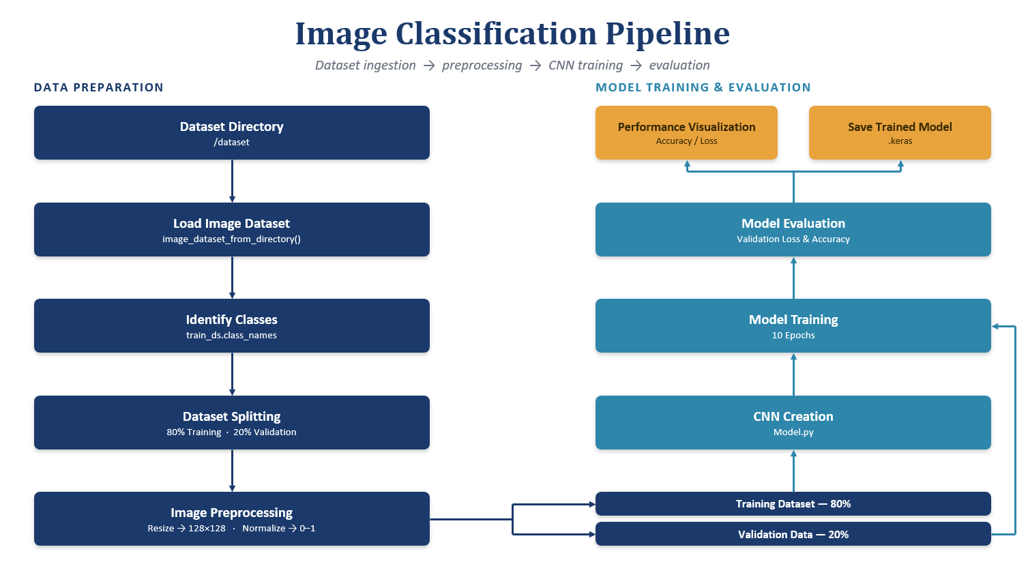

Azure DevOps Usage:
Note: Azure Setup Failed. Creating a CI/CD Pipeline in GitHub.
Whenever code is pushed to the main branch or a pull request targets main, GitHub Actions automatically checks out the project, installs the Python dependencies, validates the Python code, executes the tests, and, if all tests pass, packages the application and publishes it as a build artifact.
